Write a Python program to find those numbers which are divisible by 7 and multiple of 5, between 1500 and 2700 (both included). The numbers obtained should be printed in a comma- separated sequence in a single line

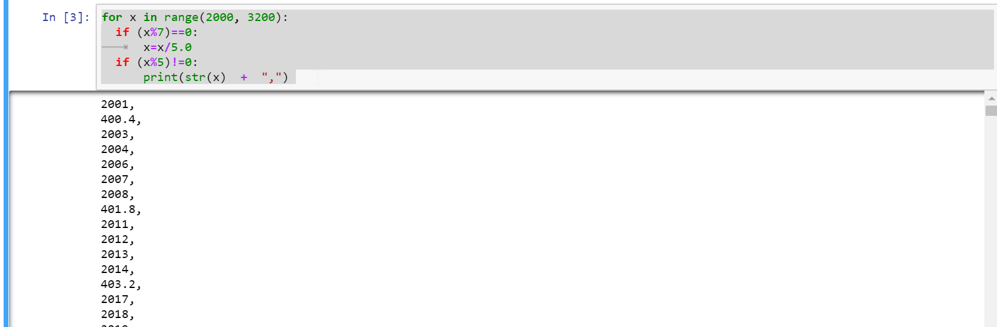

Write a Python program to accept the user's first and last name and then getting them printed

in the the reverse order with a space between first name and last name.

